PART B- TWO PORT NETWORK

- Find the z-parameters of the network shown in below figure
2. Find the z-parameters of the network shown in below figure
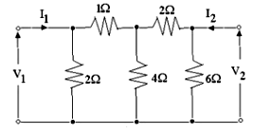
- The following direct current measurement were made on the two port network:Find h parameters
Port 1 open | Port 2 short circuited
V1= 2 mV | I1=-1 μA
V2=10 V | I2= 40 μA
I2= 100 μA | V1=5 V

- Find the transmission or general circuit parameters for the circuit shown

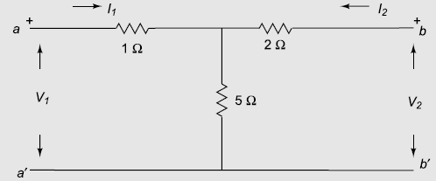
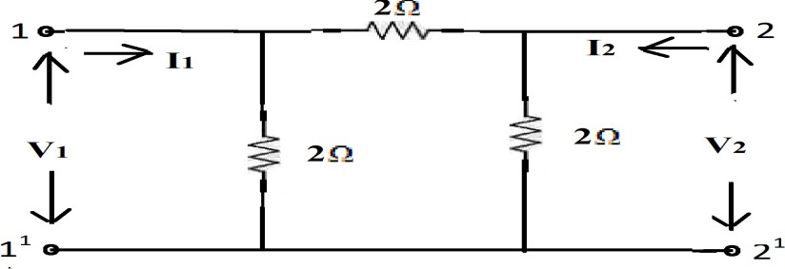
- Find the transmission parameters for the circuit shown in figure.
- Find the Short-circuit parameters for the circuit shown in figure.

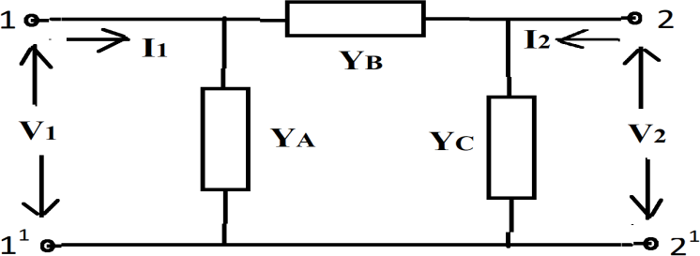
- Obtain the Condition for symmetry and Reciprocity of Z, Y, ABCD and h parameters
- Derive the relationship between hybrid and Z parameters of two port network
- Obtain the relationship of Y - Parameters in terms of h- Parameters.
- Obtain ABCD parameters of the circuit shown in figure
